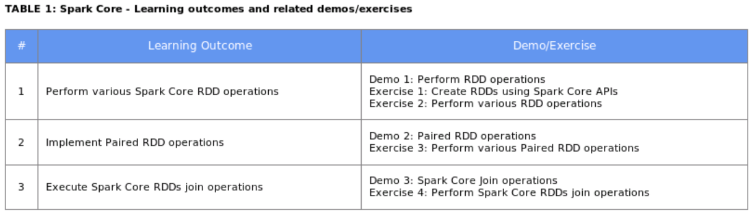

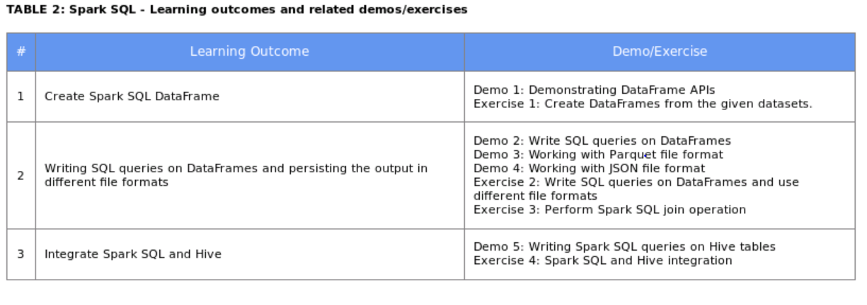

All demos are kept at user_repo/Demos path and datasets at user_repo/Datasets

Use spark-shell to open the spark environment

Copy datasets to HDFS path

To access any file from HDFS we use below command

val rdd1 = sc.textFIle(“hdfs://podSpark”); # it takes hdfs path

Spark Core Demos

Execute the commands kept inside Desktop/user_repo/Demos/SparkCoreDemo1,2,3

Spark SQL Demos

Desktop/user_repo/Demos/SparkSQLDemo1,2,3

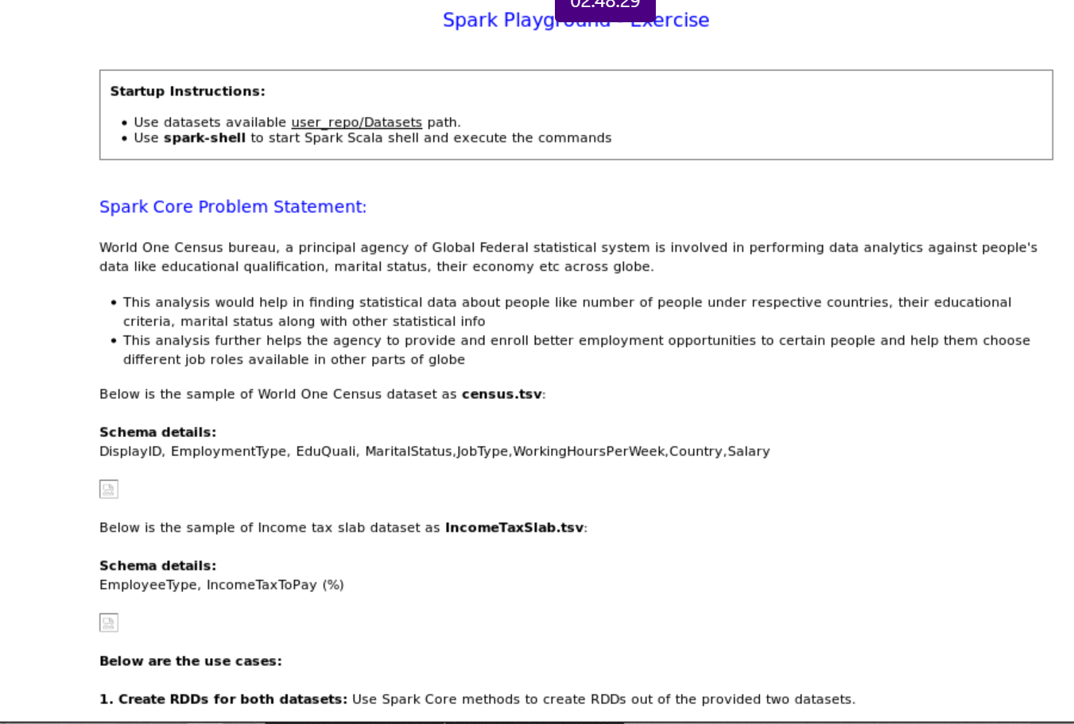

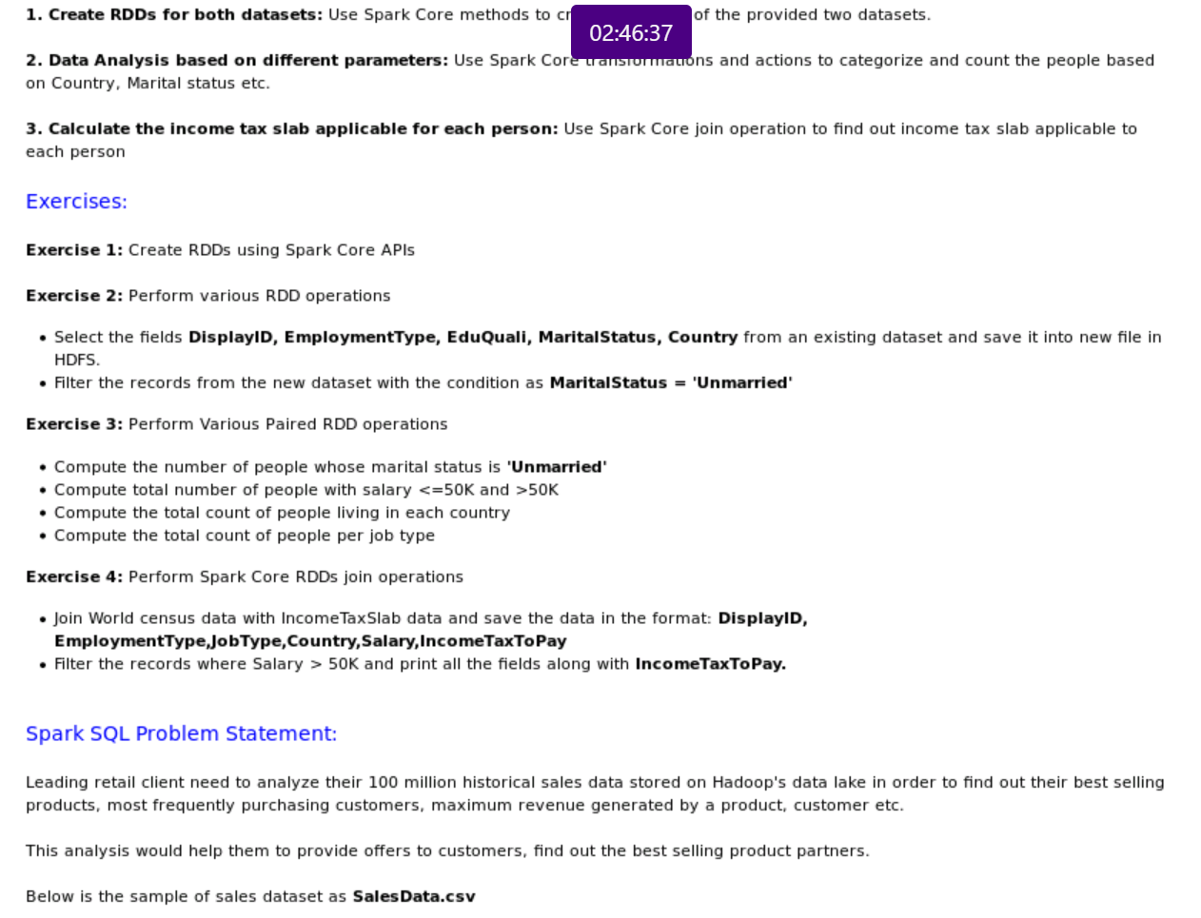

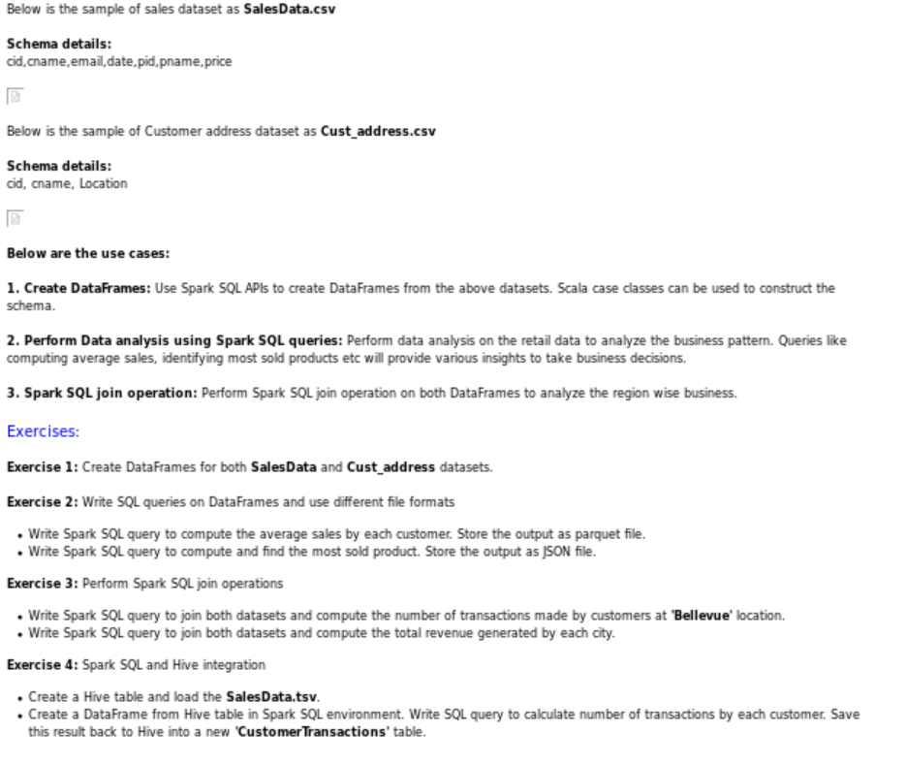

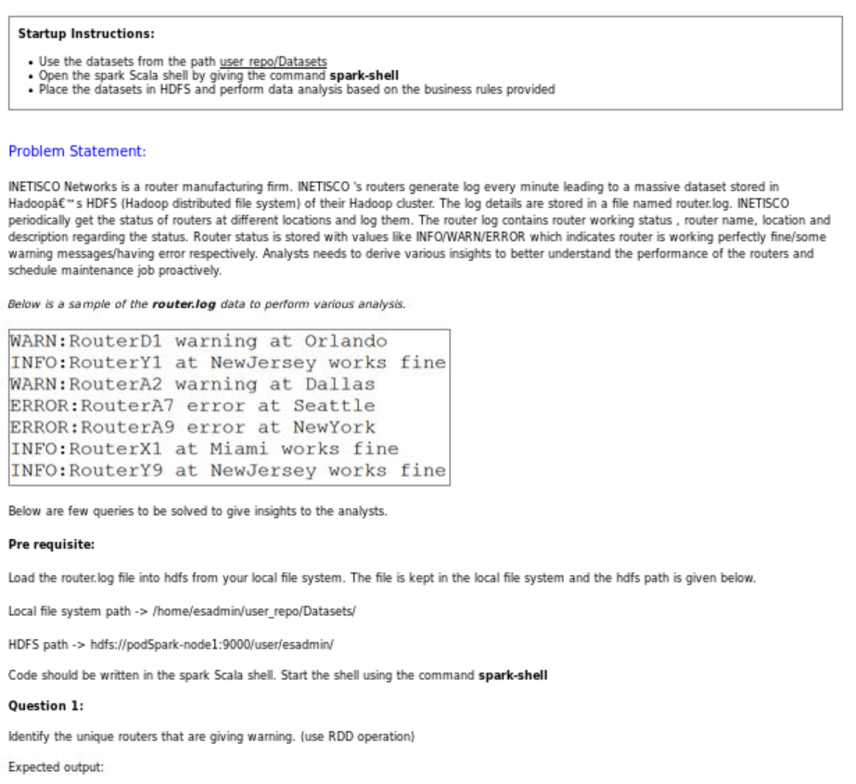

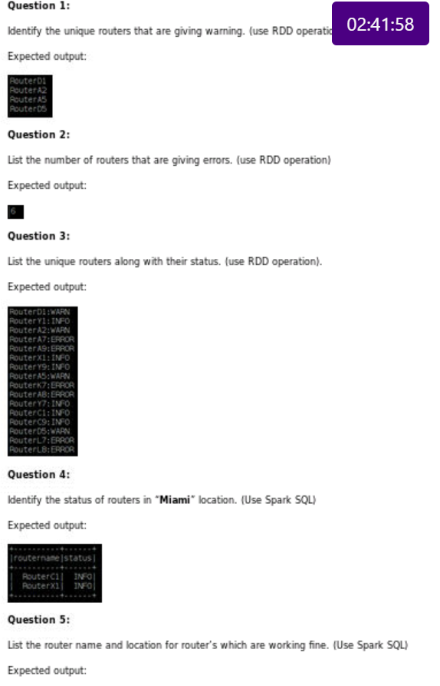

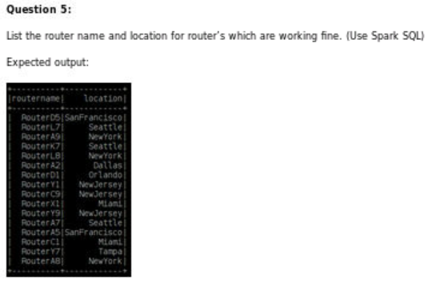

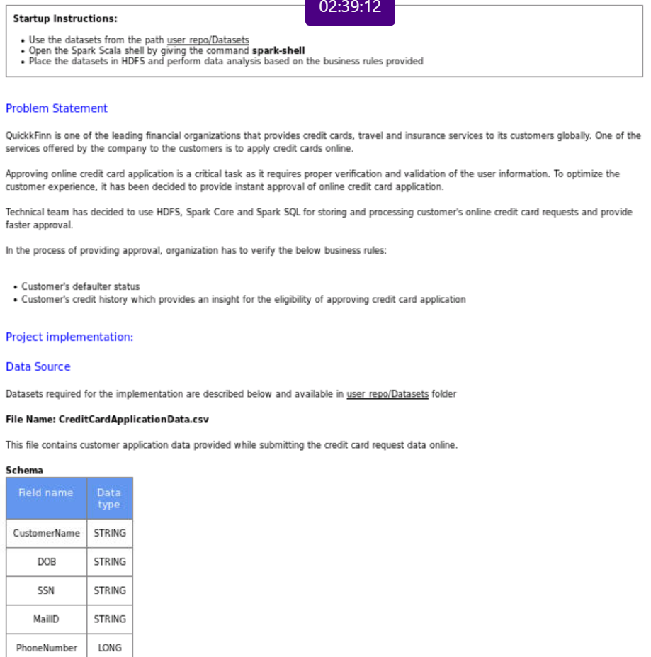

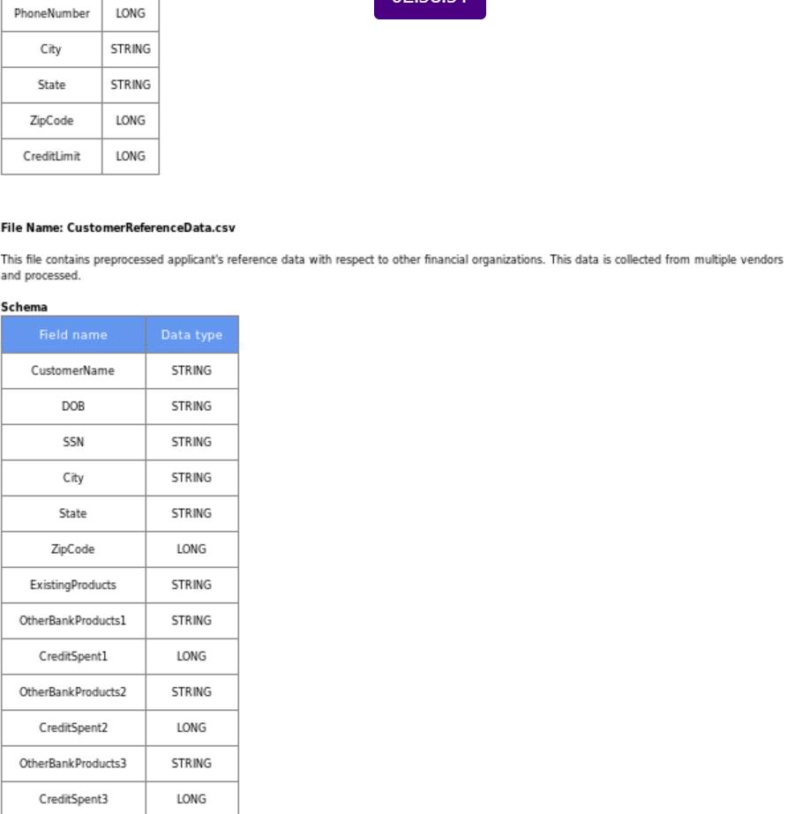

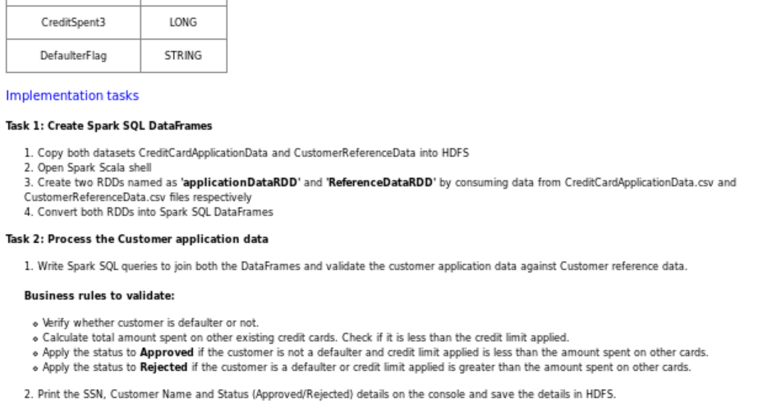

Spark Core DEMO-1

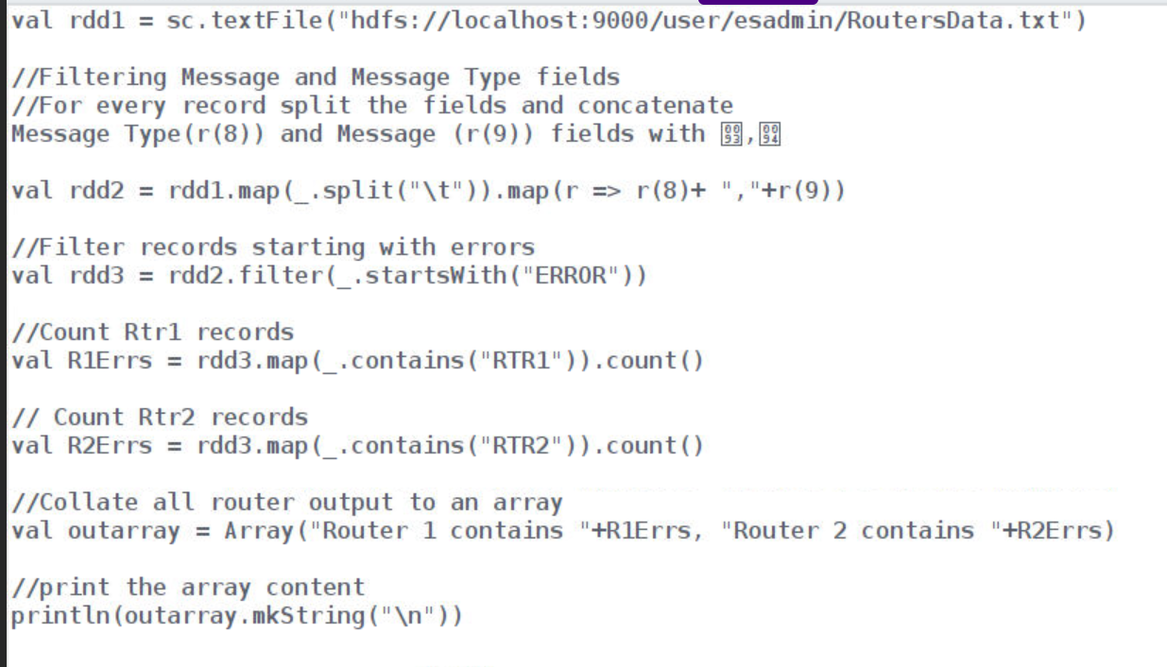

Spark Core DEMO -2

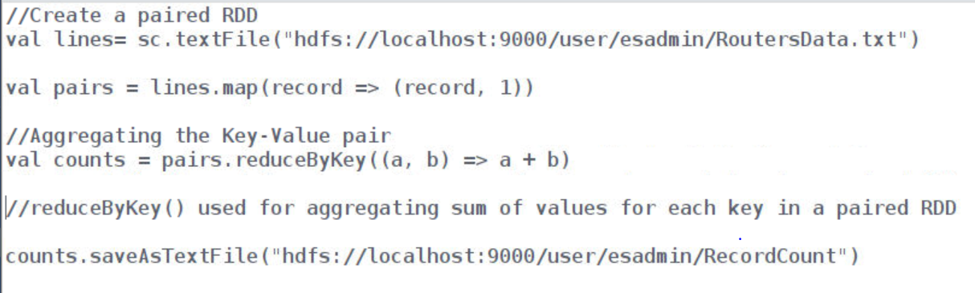

Spark Core DEMO-3

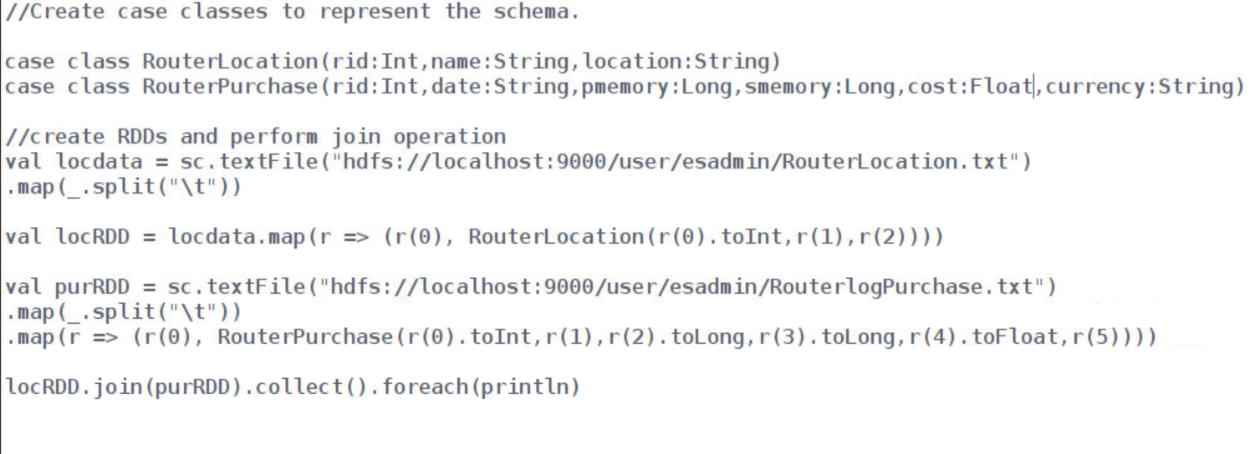

Spark-SQL DEMO -1

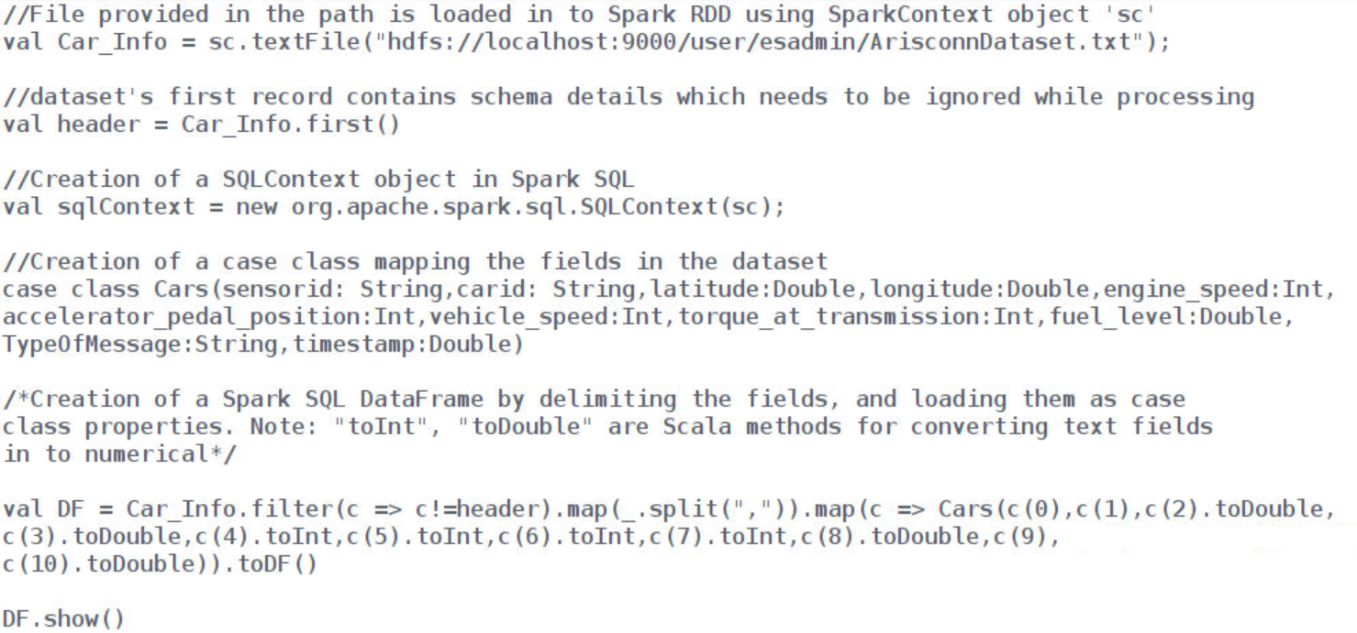

Spark-SQL DEMO -2

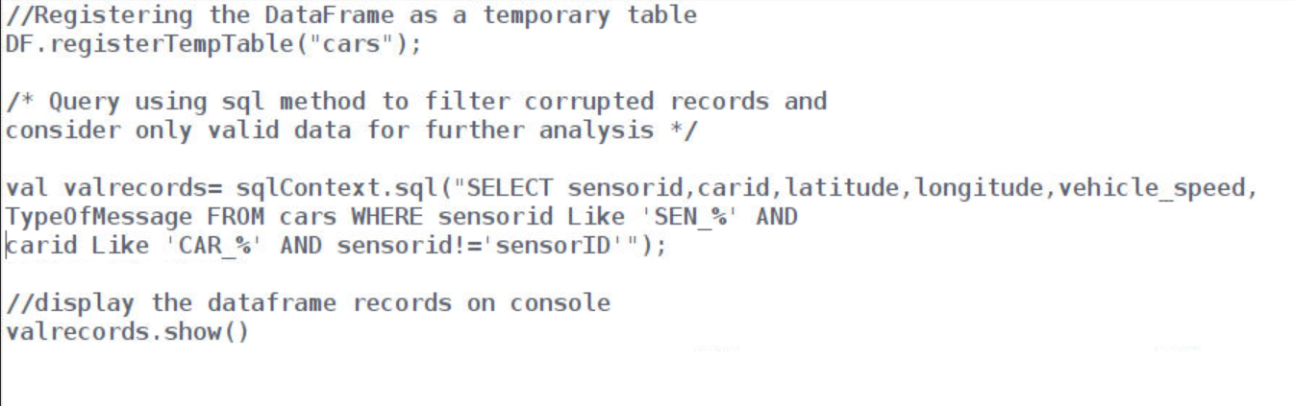

Spark-SQL DEMO -3

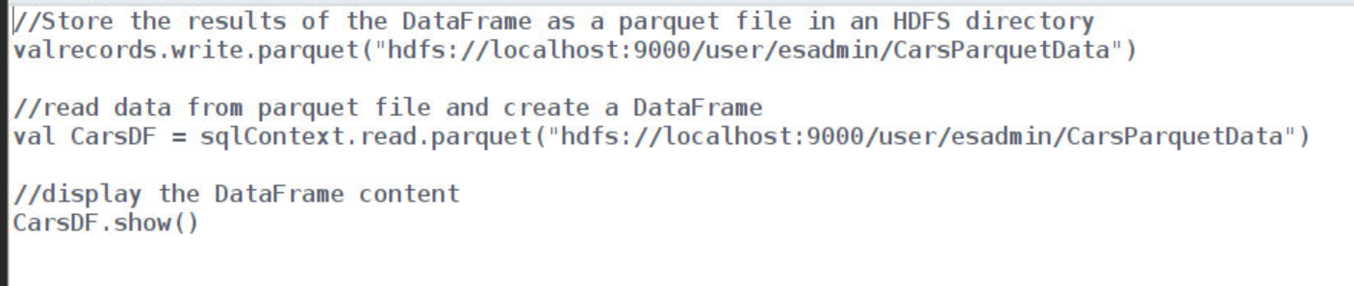

Spark-SQL DEMO -4

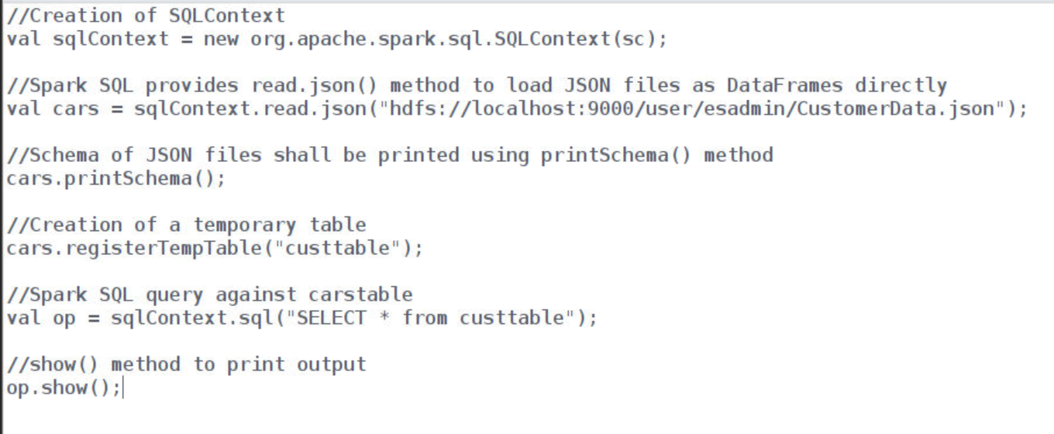

Spark-SQL DEMO -5

